**Can the contradictory effects of contact be reconciled? A study of the countervailing effects of interpersonal and frontier contact.**

Kevin Durrheim,

Mike Quayle,

John Dixon,

Philippa Kerr,

Colin Tredoux,

Brice Gijsbertsen

(Possible Journals: Personality and Social Psychology Bulletin; Group Processes and Intergroup Behaviour, Social Psychology Quarterly, psychological science)

**Abstract**

To follow….

The fact that intergroup contact can reduce prejudice must surely list among the most robust effects in social psychology research. The effect has been replicated in many hundreds of studies (Pettigrew & Tropp, 2013; Pettigrew & Tropp, 2006; Davies et al., 2011). Although Pettigrew and Tropp’s (2006) meta-analysis reported a modest overall effect size of r=-.21, they observed that better designed studies yielded stronger effects – as recent research has confirmed. Research in the past decade has also begun to answer some long standing criticisms with contact theory (Pettigrew, 1998). Whereas earlier correlational research could not disentangle causal direction, longitudinal research and complex modelling have shown that the effects operate in both directions: Less prejudiced individuals do seek out more contact over time, but, more importantly, individuals with more contact become less prejudiced over time (Eller & Abrams, 2003, 2004; Binder et al., 2009; Levin et al., 2003; Swart et al., 2011). We now also have a good idea about why contact reduces prejudice. In addition to disproving false stereotypes (Allport, 1954), contact with outgroup members can also reduce contact anxiety, deprovincialize ingroup attitudes, and foster an understanding of and empathy with outgroups (Pettigrew & Tropp, 2013).

Research has also addressed the thorny problem of effect generalization. The problem arises because contact always occurs between specific people in specific situations under particular conditions, but the effect of interest – namely, prejudice reduction – is a general effect. Some progress has been made in understanding the conditions under which contact effects generalize from individuals to groups. Contact under conditions of dual category salience is more likely to produce generalized prejudice reduction than contact that promotes decategorization or common ingroup identification (Brown & Hewstone, 2005).

However, many question still remain about the ability of contact effects to spread to different situations of intergroup contact. If contact reduces prejudice among a mixed group of friends, will non-prejudiced attitudes also be evident in an argument when friendship breaks down, or in a conflict situation with acquaintances at the workplace, with troublesome neighbours, or with strangers in public debate? These are also situations of intergroup contact. However, such conflictual contact typically produces rather than reduces prejudice. Contact researchers have long recognised the possibility that contact under non-optimal conditions can produce undesirable effects (Allport, 1954), and in the intervening years a number of studies have confirmed this (Dixon, Durrheim & Tredoux, 2005). The contradictory effects of contact limits the generalizability of contact theory for as much as the desirable effects of optimal contact may or may not spread to non-optimal contact situations, so too, the undesirable effects of non-optimal contact may infect friendship and other optimal contact. So the question about whether the contradictory effects can be reconciled is an important one for researchers that hope to promote social change.

Yet, social psychologists have hardly shown an interest in reconciling the contradictory effects of prejudice. The main reason for this is that they have typically sought optimal conditions to test their hypotheses (Dixon, Durrheim & Tredoux, 2005). Pettigrew and Tropp (2006) recognized that “the knowledge gained from past contact research is limited by its primary emphasis on positive features of the contact situation” (Pettigrew & Tropp, 2006, p. 767). This work provides a restricted understanding of how non-optimal factors, conditions, experiences, and psychological states affect the ability of contact to reduce prejudice. It has also limited our ability to understand how different kinds of contact – positive and negative – affect individuals. As a consequence it has prevented us from investigating whether the contradictory effects of contact can be reconciled.

In general, research subsequent to that covered by Pettigrew & Tropp’s (2006) meta-analysis has continued to focus on optimal conditions. This is mainly done by using a restricted range of measures to operationalize contact. By in large, these focus on friendships or good quality interpersonal acquaintance, including equal status, intimate, cooperative, and friendly contact. Friendship is of “special importance” for contact research because it “invokes many of the optimal contact conditions” (Pettigrew et al., 2011, p. 275), and is thus ideal for demonstrating a range of positive outcomes, including intergroup trust, prejudice and anxiety reduction, and a differentiated view of outgroups (Davies et al., 2011).

However, if contact theory were universally true, “one would not expect high levels of conflict, often erupting into violence, in those parts of the world where different racial and ethnic groups are in the most frequent contact” (Forbes, 2004, p. 71). Yet, such conflict between neighbors is everywhere in the global news all the time. Such observations suggest limits to the generalizability of the contact hypothesis, showing instances where contact promotes rather than reduces prejudice. Such contradictory effects are confirmed by substantial body of research in North America, Europe and South Africa that has shown that aggregate level (regional) diversity is associated with increased hostility between groups (e.g., Durrheim & Dixon, 2010; Fossett & Kiecolt, 1989; Quilian, 1995; Taylor, 1998; but see Wagner et al, 2006 and Christ, et al., 2014 for conflicting European data). A second body of literature suggests that prejudice reduction produced in contact interventions does not generalize to real world situations of conflict. Although the evidence is not conclusive (Paluck & Green, 2009), there are strong suggestions that the salutatory effects quickly dissipate when individuals return to conflict situations such as in Palestine (Hammack, 2011; Maoz, 2012). Finally, research on the re-segregation of neighborhoods and schools suggests that, in some instances, whites are prepared to accommodate a small minority of minority members, but will leave once the proportion of minority neighbors passes a tipping point, or once they imagine large scale future influx of minorities (Crowder, 2000; Charles, 2000; Fairlie & Resch, 2002).

The “paradox” or “contradiction” between the two bodies of evidence about the effects of contact is intriguing. Generally the results are explained in terms of levels of analysis. Social psychologists typically focus on the effects of interpersonal contact on individuals, whereas sociologists focus on regional contact between groups; and these forms of contact may have contradictory effects. Regional diversity promotes intergroup conflict, threat and prejudice, and undermines trust; whereas cross-group interpersonal friendships reduce intergroup conflict, threat and prejudice, and promote trust. A handful of studies have attempted to study these contradictory effects, using multi-level modelling to investigate the two effects together (Christ et al. 2014; Dixon, 2006; Stolle et al., 2008). Stolle et al. (2008) and Dixon (2006) found that the contradictory effects operated simultaneously. White Americans who live in close proximity to African Americans are less trusting and more threatened by their neighbours, but interpersonal friendships in such contexts ameliorate these effects. Although Christ et al. (2014) found that the individual and group level effects operated in the same direction and supported each other, they did not directly measure regional diversity.

Overall, this research begs the question about how the contradictory effects of contact can be reconciled. How is the psychological condition of contradictory effects managed by people? How does it translate into outcomes? When? Both the positive and negative effects may want to generalize to new situations but are limited by each other. Multi-level modelling may not be the best way to investigate these issues because diversity at an aggregate level does not necessarily mean the groups are in actual contact. It is possible to live together apart, adopting practices of segregation that reduce contact to a minimum (Tredoux & Dixon, 2009). Christ et al. (2014) allude to this possibility when they explain that “macrolevel diversity should not be equated with actual intergroup contact” (p. 4). However, measuring macro-level contact in terms of self-reports of contact norms and frequency of positive intergroup contact begs the question about whether the individual and group level data really target different kinds of contact.

In this article, we report the results of a study that sought to determine the effects of two opposing kinds of contact, both of which were measured directly. We surveyed the experiences and opinions of Indian residents of the formal neighborhood of Northdale regarding interpersonal contact and physical closeness with African residents of neighboring informal settlements. Northdale was designated an Indian residential area by apartheid legislation in South Africa, but, as elsewhere in South Africa (Reference), the end of apartheid saw the emergence of informal settlements of African shack dwellers on open land in Northdale and surrounds. The non-optimal and conflictual nature of the contact situation has been poignantly highlighted by ongoing conflict between the formal and informal residents over ‘illegal electricity connections’, crime, and falling house prices. At the same time, these are two groups where were both oppressed by apartheid and who have potential to build solidarity on the basis of shared (although not equivalent) socio-economic disadvantage (Dixon et al, in press).

We operationalized physical closeness in terms of how close the Indian participants lived to the nearest informal settlement, their subjective perceptions of closeness, and their ability to see, hear and smell their neighbors. We conceptualized closeness as ‘frontier contact’, the experience of being on or near the boundary between groups, together with the threats and possibilities this affords. We measured interpersonal contact conventionally in terms of the amount of positive contact individuals had with black people and residents of the informal settlement.

In the light of previous findings of the contradictory effects of group and individual level contact, we hypothesized that physical closeness would be associated with higher levels of prejudice, but that positive interpersonal contact would be associated with lower levels of prejudice. We expected that these prejudice effects would be mediated by the same factors, namely, threat, empathy and negative emotions.

**Method**

**Sample**

We subdivided the Northdale population into three strata – immediate neighbours of the Hlalakahle informal settlement, residences in eyeshot of an informal settlement, and the remainder – and we selected a stratified random sample, oversampling households in the two closer strata. We used the last birthday method (O’Rourke & Blair, 1983) to identify individual adult respondents in selected households. The sample consisted of n = 365 self-identified Indian adult South African residents (185 females) whose mean age was 45.43 years (SD = 14.97), ranging from 18 to 84 years. We were unable to contact members of 53 households, who were not at home on 3 occasions. A further 82 eligible people refused to participate in the survey. Together, this gives us a non-response rate of .27. The final sample represents 4.36% of the residential households in Northdale.

**Procedure**

Questionnaires were administered by seven research assistants who were Indian students living in Northdale or surrounding suburbs. They visited selected households, selected individual participants, and administered the questionnaire by asking participants to complete the paper-and-pencil survey themselves. In a small minority of cases where participants were not able to complete questionnaires themselves, the research assistants were instructed to read the questions out aloud while marking participants’ answers in the questionnaire.

**Materials**

The survey consisted of items adapted from measures used in previous research, as well as items designed to capture features specific to the Northdale context. For all items, participants responded on Likert-type scales ranging from 0 (strongly disagree) to 4 (strongly agree), which were reverse scored where necessary.

*Contact Quality.* Contact quality was measured by three items, adapted from Islam and Hewstone’s (1993) Qualitative Aspects of Contact scale (α = .89): “When I come into contact with people from informal settlements, we generally cooperate well with each other”, “When I come into contact with people from informal settlements, we almost always interact as equals”, and “When I come into contact with people from informal settlements, contact is almost always friendly”. (Cronbach alpha= .91).

*Closeness*. We created a composite measure of physical closeness to the nearest informal settlement, using the following indicators, which were all highly inter-correlated: (1) Physical closeness (the inverse of the ‘crow flies’ distance from the household to the nearest informal settlement, calculated using Google maps, with range 0 to 1); (2) self-reported perception of closeness to the nearest informal settlement, measured on a 5-piont scale ranging from ‘very close’ to ‘very far away’; and the visceral experience of closeness indicated by self-reported ability to (3) see, (4) hear, or (5) smell an informal settlement from their house or garden.

*Prejudice*. Prejudice towards people who live in informal settlements was measured by means of a five-item semantic differential scale (Zanna, 1994) on which respondents rated (on 10 point scales) how they felt about members of the outgroup: (1) Negative – Positive, (2) Cold – Warm, (3) Hostile – Friendly, (4) Suspicious – Trusting, (5) Disrespect – Respect (Cronbach’s alpha =.71)

*Threat*. We operationalised threat in physical terms, using a 3-item scale adapted from Schmidt et al (1998): (1) I worry about crime committed by informal settlement residents; (2) I worry about being physically attacked by informal settlement residents; (3) I worry about my personal property being damaged by informal settlement residents. The scale was reliable (Cronbach’s alpha = .88).

*Empathy*. We used Wang et al.’s (2003) four-item empathic awareness scale: (1) I am aware of how society differentially treats people who live in informal settlements; (2) I recognize that the media often portrays residents of informal settlements negatively, (3) I can see how people who live in informal settlements are systematically oppressed in our society; (4) I am aware of institutional barriers (e.g., restricted access to jobs and healthcare) that discriminate against people who live in informal settlements.

*Negative emotions*. We measured 8 negative emotions (angry, irritated, worried, afraid, hopeless, desperate, disgusted, repulsed), asking participants to report how much they felt each emotion – using a 5 point scale ranging from ‘not at all’ to ‘extremely’ – when they thought about informal settlements getting larger in size in Northdale. (Cronbach’s alpha = .98).

**Results**

The descriptive statistics reported in Table 1 show that the sample experienced high levels of threat. In contrast to the other measured variables, which were approximately normally distributed, Threat was negatively skewed. However, the skew was not severe (indeed, the skewness statistic for all measured variables was <|1|)

|  |
| --- |
| Insert Table 1 about here |

We created a composite measure of closeness by computing the first principal component of physical closeness, subjective closeness and the three visceral closeness measures. The factor loadings were all greater than .72, and this single dimension accounted for 61% of the variance of the five indicators. Closeness represented a form of contact associated with living on the frontier between groups, where contact not only took the form of physical closeness and associated perceptions of closeness; it was also associated with an ability to see, hear and smell one’s neighbours.

Not surprisingly, the closer participants lived to an informal settlement, the more threat they experienced (r=.29). The relationship is well illustrated graphically in Figure 1, which shows the geographic distribution of threat in Northdale.[1] The map exposes the frontier, showing that pockets of threat exist in areas in the immediate proximity to or in eyeshot of the informal settlements. It also shows how the physical geography of Northdale affects the experience of threat. Most notably, the lowest levels of threat are experienced by residents living in the regions geographically separated from the informal settlements by streams.

|  |
| --- |
| Insert Figure 1 about here |

We modelled the way closeness affected prejudice through the mediators of threat, empathy and negative emotions, with Structural Equation Models. We first estimated the saturated model by specifying all paths between standardized measures of closeness, the mediators and the outcomes. We then removed all paths with p-values >.05. Closeness was not directly related with prejudice (r = .04) but the resultant model (see Figure 2) shows that an indirect relationship existed between closeness and prejudice, entirely mediated by experiences of threat and negative emotions. Individuals who lived close to an informal settlement felt threatened and reported negative emotions, which in turn were associated with higher levels of prejudice in comparison with those who lived further away.

|  |
| --- |
| Insert Figure 2 about here |

We used the same method to model the way contact quality affected prejudice through the mediators of threat, empathy and negative emotions. Once we had defined a model for the sample as a whole, we examined the moderating effect of closeness by replicating the analysis for participants who lived close to (weights above the paths in Figure 3) or far from an informal settlement (weights below the paths in Figure 3). We did this by using a mean split of the composite closeness variable.

The RMSEA for the model for participants living in the immediate proximity of informal settlement was not significant. However, contact quality was associated with threat, empathy and prejudice.

Neither threat nor empathy mediated the relationship between contact quality and prejudice. Good quality contact with residents of informal settlements – mostly likely in employment relationship with domestic workers – reduced prejudice toward residents of informal settlements but this relationship was not affected by the decreased threat and increase empathy that was also associated with good quality contact. Presumably these residents already experienced high levels of threat associated with falling house prices and the possibility of crime and negative emotions being linked being e.g. being disturbed by noise, affected by electricity theft, etc. In this context, good quality contact reduces prejudice and promotes empathy with the plight of people living in informal settlements, but these effects are independent of and do not ameliorate the negative effects of threat and negative emotions.

The model for participants living further away from informal settlements is similar. There is a strong direct negative effect between contact quality and prejudice. In addition, good quality contact affects prejudice by reducing negative emotions. At the same time quality contact is associated with reduced threat and increased empathy, but these mediators were not associated with prejudice.

|  |
| --- |
| Insert Figure 3 about here |

**Conclusion**

The primary aim of this article was to investigate the contradictory effects of contact. Is it possible that contact can both reduce and increase prejudice? A large literature in social psychology has demonstrated that good quality interpersonal contact reduces prejudice (Pettigrew & Tropp, 2006; 2013). At the same time, research on neighbourhood diversity, neighbourhood re-segregation, and the consequences of contact in conflict situations indicates that intergroup contact might actually promote hostile and prejudiced attitudes. This begs the question about whether these contradictory effects can be reconciled. What are the limits to the generalizability of each of the contradictory effects; and how do individuals manage the contradiction?

To investigate these questions, we coined the term ‘frontier contact’ to describe a form of contact associated with living on the boundaries between groups. We defined the concept spatially and experientially in terms of physical closeness, subjective perceptions of closeness, and the visceral experience of being able to see, hear and smell the outgroup. This definition was appropriate to the close residential contact between formal and informal residents we studied, but the spatial condition and experience of being on a frontier between groups may take many forms, as is testified to by the variety of migrations and segregations among the populations of the world, old and new.

We get a glimpse of the social psychological experience of frontier contact from the map depicting the geographic distribution of threat across Northdale (Figure 1). Residents living in the immediate physical proximity or in eyeshot of an informal settlement were more likely to feel threatened by the possibility of crime, physical attack and damage to property. On the other hand, those areas of the neighbourhood that were physically separated from informal settlements by streams were far less likely to experience such threat.

We investigated the contradictory effects of interpersonal and frontier contract by running a series of structural equation models, investigating how each kind of contact affected prejudice, through the mediators of threat, empathy and negative emotions. Past research has shown that these variables mediate the relationship between interpersonal contact and prejudice reduction. We sought to determine whether the same factors would mediate the relationship between frontier contact and prejudice production. Figure 2 shows that frontier contact was not directly correlated with prejudice, but had a powerful effect on prejudice through the mediating variables of threat and negative emotions. Staying near to an informal settlement promoted threat and negative emotions, which in turn increased prejudice. It is unlikely that more residents with higher levels of threat and negative emotions chose to live near informal settlements, giving grounds to believe that the effects are in the causal direction depicted by the model.

In direct contrast to these effects and in line with the expectations of contact theory, good quality interpersonal contact was directly associated with reduced prejudice. This effect was equally strong for residents living in the threat regions near to or far away from the informal settlements. In addition for those living far from informal settlements, the prejudice reduction effect of good quality interpersonal contact was attributable to reduce negative emotions. Surprisingly, the reduced threat and increased empathy associated with good quality contact did not translate into reduced prejudice, among either of the samples living close to or far from an informal settlement.

Together, the results paint a picture of a complex and contradictory experience of intergroup contact. Frontier contact promotes threat, negative emotions and prejudice, whereas interpersonal contact reduces prejudice. The contradictory effects operate alongside each other, without one effect generalizing to, or gradually superseding, or taking over the other. The residents of Northdale manifested a remarkable ability to partition and compartmentalize rather than generalize the contradictory effects. Living near to an informal settlement prompted fears about crime and attack and negative emotions of anger, worry, fear and disgust, and these translated into increase prejudice. On the other hand, good quality contact with individuals from the informal settlement promoted empathy for the plight of people living in these conditions, and it reduced threat and prejudice. However, these beneficial effects do not eradicate the threat associated with potential criminal activity emanating from the informal settlements.

These findings have potential to shape policies that support social change. Traditionally, the power of contact to effect social change rests on its ability to generalize from particular instances of contact, with particular individuals, under particular conditions, to the target group as a whole. Recent arguments have voiced concern about prejudice reduction as a paradigm for social change, arguing that prejudice reduction may help to entrench inequality (Dixon, Levine, Reicher & Durrheim, 2012; Wright & Baray, 2012). The compartmentalization of contradictory contact effects suggests alternative strategies to promote social change. For example, efforts to reduce prejudice through good quality contact interventions in Northdale might be doomed to failure given the nature of the threats. Nonetheless, the empathy that these relatively poor and historically oppressed Indian residents have with their even poorer, marginalized and oppressed neighbours is potentially the foundation of solidarity between these groups and the basis for collective action. The question then is how to foster empathy, solidarity and the kind of collective action that would promote genuine social change?

In conclusion, we return to the question in the title of this article: Can the contradictory effects of contact be reconciled? Our data suggests that there is no contradiction at all. Rather, differ kinds of contact have different effects. The effects of contact only appear contradictory when they are assumed to be of a single kind. For example, Pettigrew et al. (2011) claim that “contact’s effects are far greater for majorities than for minorities” (p. 278). They assume that the effects of contact are of a single kind, but differ quantitatively between majorities and minorities. Recent research suggests however, that the effects of contact are qualitatively different for majorities and minorities. Good quality interpersonal contact strengthens social change orientation and associated variables among majorities, but weakens them among minorities (Dixon et al., 2013).

Different kinds of contact have different effects. Sometimes these different kinds of contact can pull in different directions. Frontier contact promotes fear and uncertainty, but it also offers opportunities for encounter, exchange and friendship, and it holds the promise of something new, and of social change. The challenge is to understand how particular kinds of contact translate into particular outcomes. Further research of this phenomenon would do well to include qualitative studies of the kind of contact and its outcome (e.g., Durrheim & Dixon 2005; Durrheim, Jacobs & Dixon, 2014). Such work will show not only the different ‘working models of contact’ (ref here, Durrheim & Dixon, 2005?) of majority and minority groups in contact, but also how these working models shape and are shaped by history, the nature of interactions, and the material conditions of their contact.

**References**

Allport, G.W. (1954). *The nature of prejudice*. Garden City, NY: Doubleday.

Binder, J., Brown, R., Zagefka, H., Funke, F., Kessler, T., Mummendey, A., Maquil, A., Demoulin, S. and Leyens, J. (2009). Does contact reduce prejudice or does prejudice reduce contact? A longitudinal test of the contact hypothesis among majority and minority groups in three European countries. *Journal of Personality and Social Psychology, 96,* 843-856.

Brown, R., & Hewstone, M. (2005). An integrative theory of intergroup contact. In: M.P. Zanna (ed.) *Advances in Experimental Social Psychology.* Academic Press, San Diego, pp. 255-343.

Charles, C. Z. (2000). Neighborhood racial-composition preferences: Evidence from a multiethnic metropolis. *Social Problems*, *47*, 379-407.

Christ. O., Schmid, C., Lolliot, S., Swart, H., Stollee, D., Tausch, N., Ramiah, A., Wagner, U., Vertovech, S., & Hewstone, M. (2014). Contextual effect of positive intergroup contact on outgroup prejudice. *Proceedings of the National Academy of Sciences*. doi: 10.1073/pnas.1320901111

Crowder, K. (2000). The racial context of white mobility: An individual-level analysis of the white flight hypothesis. *Social Science Research*, *29*, 223–57.

Davies, K., Tropp, L. R., Aron, A., Pettigrew, T. F., & Wright, S. C. (2011). Cross-group friendships and intergroup attitudes: A meta-analytic review. *Personality and Social Psychology Review*, *15*, 332-351.

Dixon, J. C. (2006). The ties that bind and those that don't: Toward reconciling group threat and contact theories of prejudice. *Social Forces*, *84*, 2179-220

Dixon, J., Durrheim, K., & Tredoux, C. (2005). A reality check for the contact hypothesis. *American Psychologist, 60*, 697-711.

Dixon, J., Durrheim, K., Thomae, M., Tredoux, C., & Kerr, P. (in press). Divide and rule, unite and resist: Contact, collective action and policy attitudes amongst historically disadvantaged groups. *Journal of Social Issues*.

Dixon, J., Durrheim, K., Kerr, P., & Thomae, M. (2013). ‘What’s so funny ‘bout peace, love and understanding’? Further reflections on the limits of prejudice reduction as a model of social change**.** Journal of Social and Political Psychology.

Dixon, J., Levine, M., Reicher, S., & Durrheim, K., (2012). Beyond prejudice: Are negative evaluations the problem? Is getting us to like one another more the solution? *Behavioral and Brain Sciences*, 36, 1-16.

Durrheim, K., & Dixon, J. (2010). Racial Contact and Change in South Africa. *Journal of Social Issues*, *66*, 273-288.

Durrheim, K. & Dixon, J. (2005). *Racial encounter: The social psychology of contact and desegregation*. London: Routledge.

Durrheim, K., Jacobs, N., & Dixon, J. (2013). Explaining the paradoxical effects of intergroup contact: Paternalistic relations and system justification in domestic labour in South Africa. *International Journal of Intercultural Studies*. http://dx.doi.org/10.1016/j.ijintrel.2013.11.006.

Eller, A., & Abrams, D. (2003). “Gringos” in Mexico: Cross-sectional and longitudinal effects of language school-promoted contact on intergroup bias. *Group Processes and Intergroup Relations, 6,* 55–75.

Eller, A., & Abrams, D. (2004). Come together: Longitudinal comparisons of Pettigrew’s reformulated intergroup contact model and the common ingroup identity model in Anglo-French and Mexican-American contexts. *European Journal of Social Psychology, 34,* 229–256.

Fairlie, R. W., Resch, A. M., (200). Is there ‘white ﬂight’ into private schools? Evidence from the

National Educational Longitudinal Survey. Review of Economics and Statistics,

Forbes, H. (2004). Ethnic conflict and the contact hypothesis. In Y. T. Lee, C. McAuley, F. Moghaddam, & S.Worchel (Eds.), *The psychology of ethnic and cultural conflict* (pp. 69–88). New York: Praeger.

Fossett, M. & Kiecolt, K. J. (1989). The relative size of minority populations and white racial attitudes. *Social Science Quarterly*, *70*, 820-35.

Hammack, P. L. (2011). *Narrative and the politics of identity: The cultural psychology of Israeli and Palestinian youth*. New York: Oxford University Press.

Islam, M. R., & Hewstone, M. (1993). Dimensions of contact as predictors of intergroup anxiety, perceived out-group variability, and outgroup attitude: An integrative model. *Personality and Social Psychology Bulletin, 19*, 700-710.

Levin, S., van Laar, C., & Sidanius, J. (2003). The effects of ingroup and outgroup friendships on ethnic attitudes in college: A longitudinal study. *Group Processes and Intergroup Relations*, *6*, 76–92.

Maoz, I. (2012). Contact and social change in an ongoing asymmetrical conflict: four social-psychological models of reconciliation-aimed planned encounters between Israeli Jews and Palestinians. In J. Dixon & M. Levine (Eds). *Beyond the prejudice problematic*. Cambridge. Cambridge University Press.

O’Rourke, D. & Blair, J. (1983). Improving random respondent selection in telephone surveys. *Journal of Marketing Research*, *20*, 428-432

Quilian, L. (1995). Prejudice as a response to perceived group threat: Population composition and anti-immigrant and racial prejudice in Europe. *American Sociological Review*, *60*, 586-611.

Paluck, E. L., & Green, D. P. (2009). Prejudice reduction: What works? A review and assessment of research and practice. *Annual Review of Psychology*, *60*, 339-367.

Pettigrew, T. F., & Tropp, L. R. (2011). *When groups meet: The dynamics of intergroup conflict*. Philadelphia, PA: Psychology Press.

Pettigrew, T.F. & Tropp, L.R. (2006). A Meta-analytic test of intergroup contact theory. *Journal of Personality and Social Psychology, 90,* 751-783.

Pettigrew, T. F., Tropp, L. R., Wagner, U., & Christ, O. (2011). Recent advances in intergroup contact theory. *International Journal of Intercultural Relations*, *35*, 271-280.

Stolle, D., Soroka, S., &Johnston, R. (2008). When does diversity erode trust? Neighborhood diversity, interpersonal trust and the mediating effect of social interactions. *Political Studies*, *56*, 57–75.

Swart, H., Christ, O., Hewstone, M. and Voci, A. (2011). Affective mediators of intergroup contact: A three-wave longitudinal study in South Africa. *Journal of Personality and Social Psychology, 101,* 1221-1238.

Taylor, M. C., (1998). How white attitudes vary with the racial composition of local populations: Numbers count. *American Sociological Review*, *63*, 512-535.

Tredoux, C. G., & Dixon, J. (2009). Mapping the multiple contexts of racial isolation: The case of Long Street, Cape Town. Urban Studies, *46*, 761–777. DOI: 10.1177/0042098009102128

Wagner, U., Christ, O., Pettigrew, T. F., Stellmacher, J., & Wolf, C. (2006). Prejudice and minority proportion: Contact instead of threat effects. *Social Psychology Quarterly*, *69*, 380-390.

Wang, Y., Davidson, M., Yakushko. O.F., Savoy, H.B., Tan, J.A., & Bleier, J. K. (2003). The scale of ethnocultural empathy: Development, validation, and reliability. *Journal of Counseling Psychology*, *50*, 221–234.

Wright, S. C. & Baray, G. (2012). Models of social change in social psychology: Collective action or prejudice reduction, conflict or harmony. In John Dixon & Mark Levine (Eds.) *Beyond Prejudice: Extending the social psychology of intergroup conflict, inequality and social change* (pp. 225-247). Cambridge UK: Cambridge University Press.

Zanna, M. P. (1994). On the nature of prejudice. *Canadian Psychology*, *35*, 11-23.

**Table 1**. Descriptive statistics

|  |  |  |  |
| --- | --- | --- | --- |
|  | Mean | Std.Dev | alpha |
| Threat  Empathy  Emotions  Prejudice  Contact Quality | 3.13  2.31  2.43  2.08  2.14 | .88  .85  1.30  .96  .88 | .88  .94  .98  .71  .89 |

Note. All measures are scored on a range from 0 to 4.

**Figure 1.** Experiences of threat in Northdale.

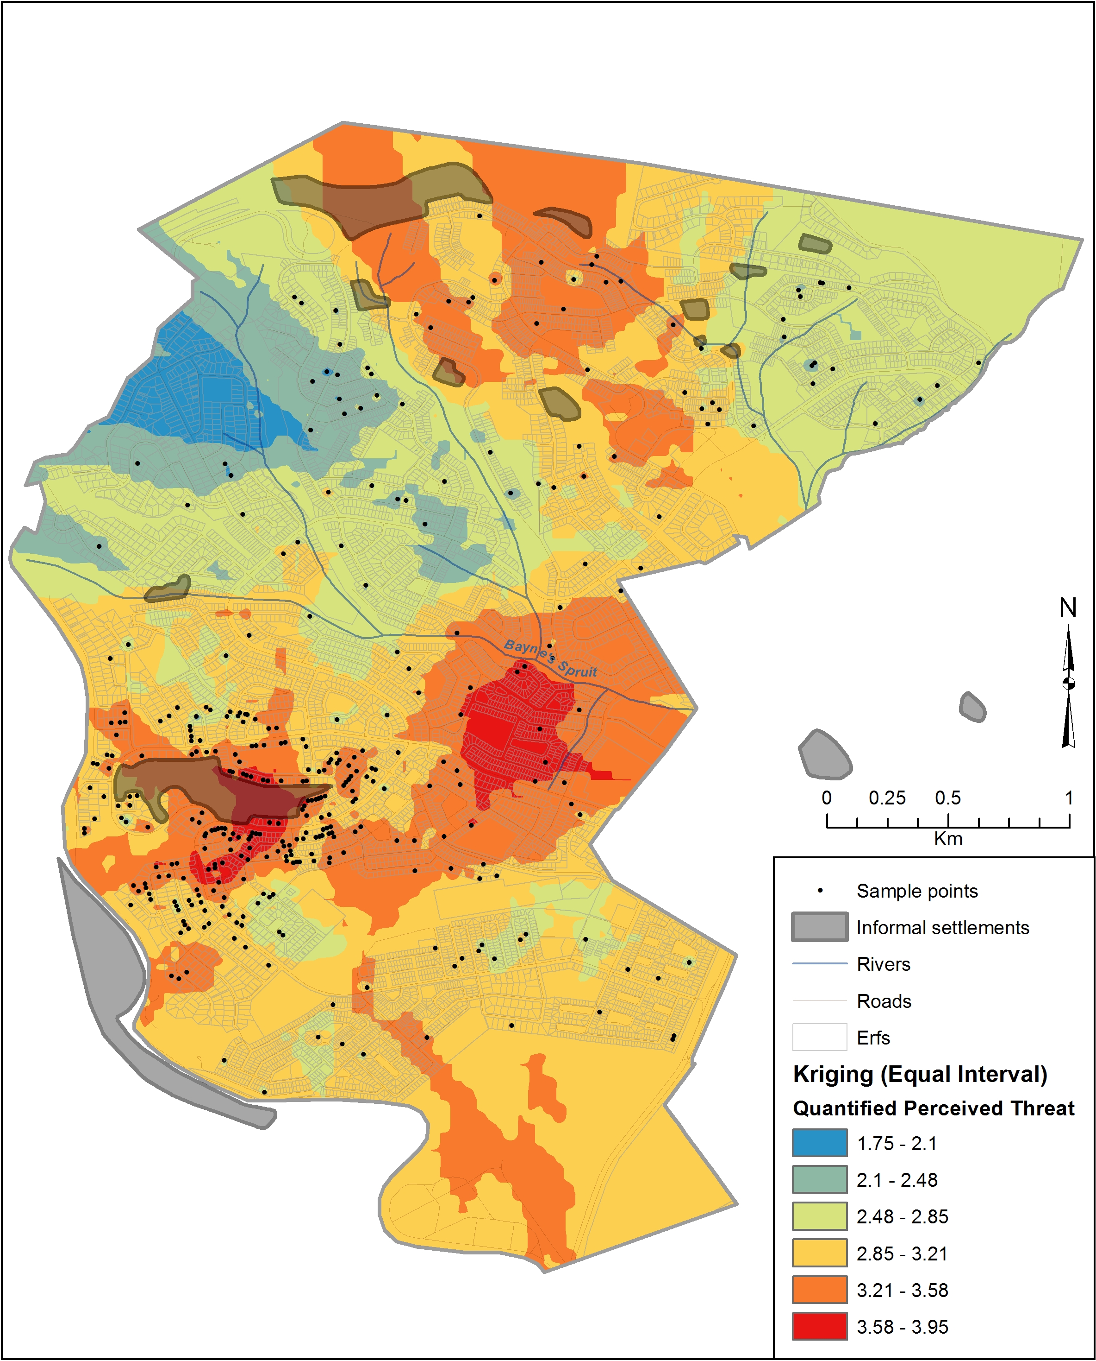

**Figure 2.** Model of the effects of closeness to an informal settlement

Shouldn’t this be ‘Physical Closeness’?

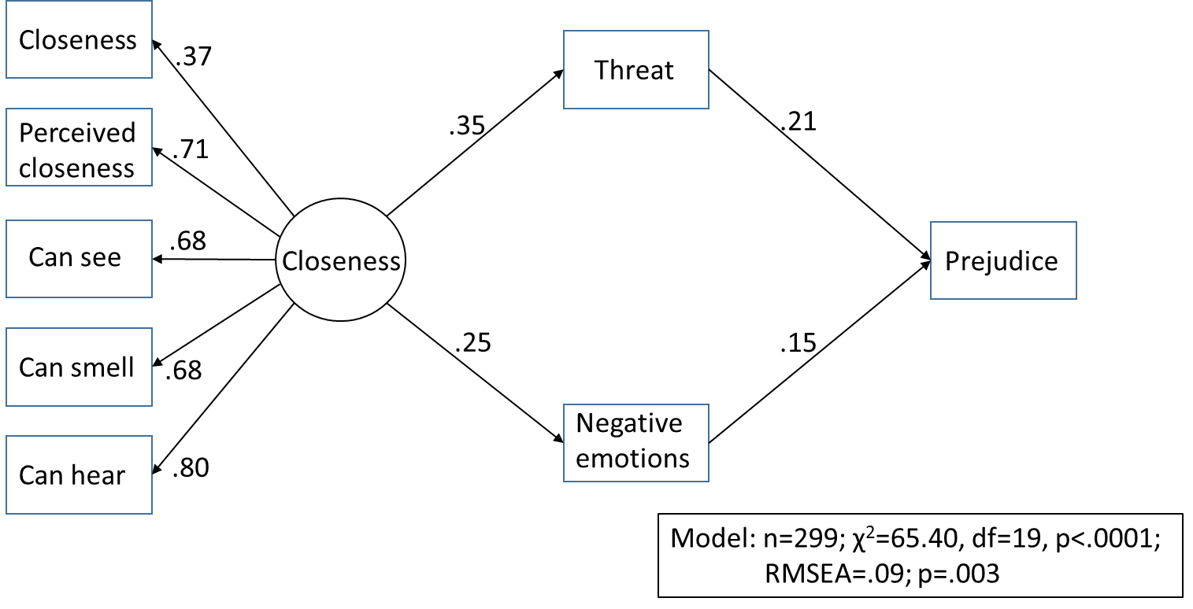

**Figure 3**. Model of the effects of good quality contact with informal settlement residents.

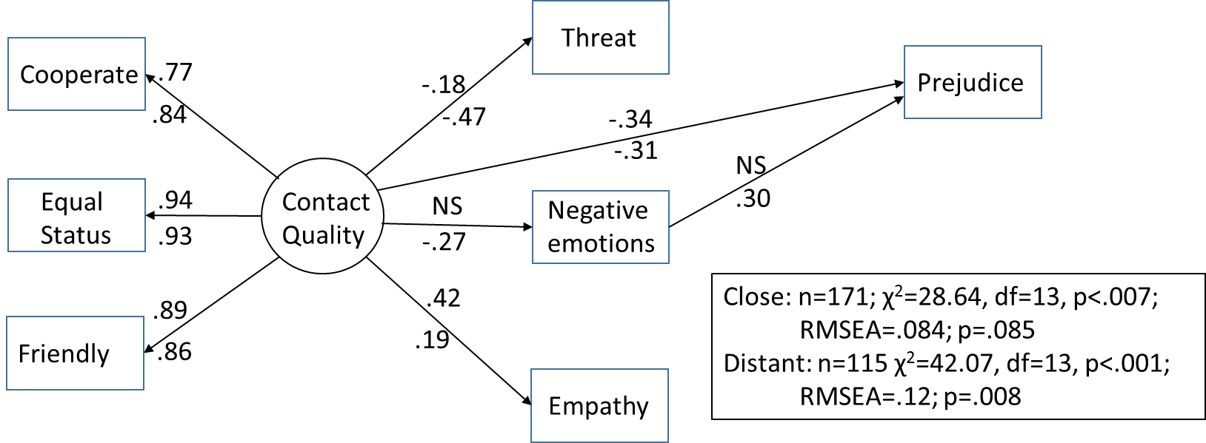

Note. Standardized regression coefficients for the model for participants living close to informal settlements are represented above the paths; Standardized regression coefficients for the model for participants living close to informal settlements are represented below the paths

1. The analysis was undertaken in ArcInfo 10.2 using an Ordinary Kriging interpolation with a spherical algorithm utilizing a spatially variable search window of 12 data points. In essence this means that for closely clustered points the spatial extent of overlapping points is smaller than those further apart but the standard interpolation utilizes the 12 closest points around each pixel to create the surface. Raster resolution is 10 metres.

   The scientific explanation of Kriging is as follows: Unlike plain Inverse distance weighting which assumes the influence of a point diminishes away from the point at a constant rate, Kriging factors in distance and direction when calculating spatial correlation. It statistically examines the data, then fits a modelled variogram and using this variogram it creates a surface. It is most appropriate where there are spatial correlations or relationships between points particularly distance and direction, such as modelling wetlands based on water depth or soil type.